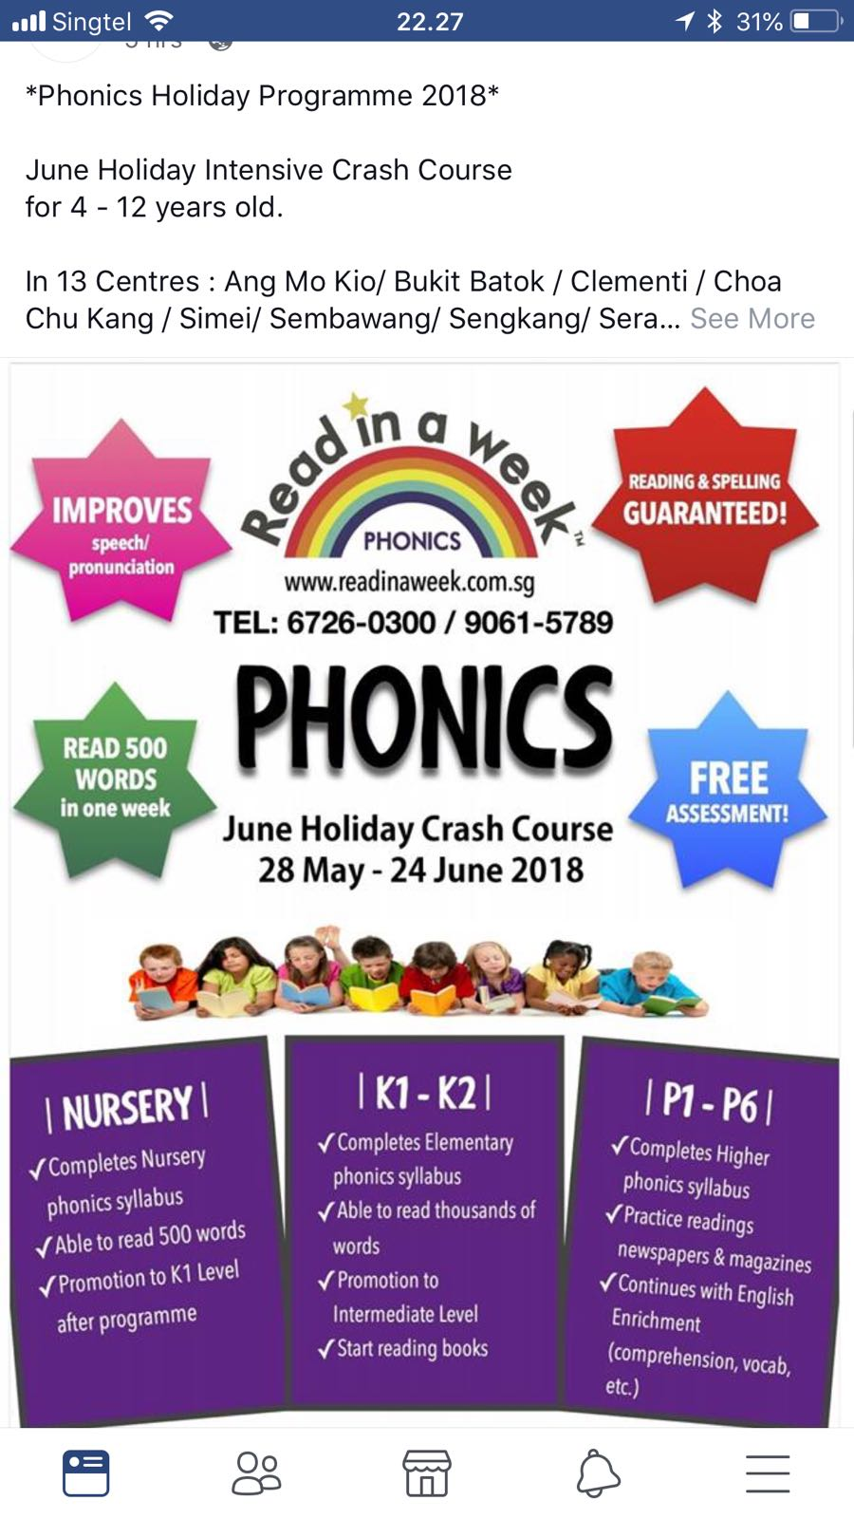

I m sending you on e flyer of someone else
There are certain things to be changed
1)Read in a Month
2)Mobile Nos-9643220619,8949
3)Summer Phonics crash course in place of june holiday crash course
4)Nursery is to be replaced by Level -I
5)Also in place of completes nursery- it should be completes KG syllabus
6) read 500 words in a month
7)In place of K1-K2 -it should be Level-2
8) in place of p1-p2- it should be Level-3
9) 14th May-12th June
10) Age group 4-5.5years
11)promotion to level 2
13) promotion to level-3
14) www.readinweek.com is to be deleted

