Prototype Development
Client Logos
Banner

Mobile App Prototyping and Strategy
Because app prototype planning resolves everything

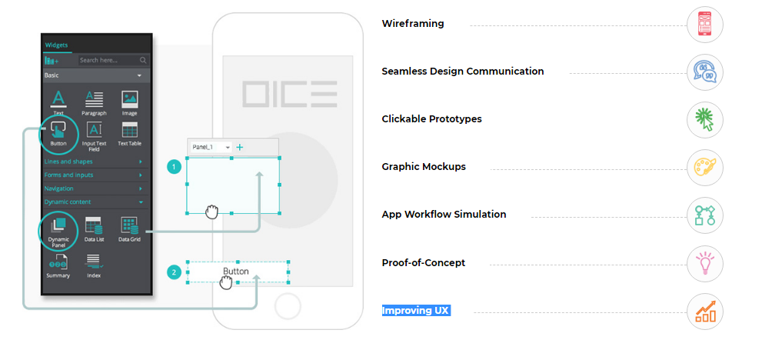
Prototype development is one of the very important pacing-stone before finishing an iPhone app development project. The turn of prototype development comes when we are done with creation of mockup wireframe service for the iPhone app. As the things become clearer before designing of final product, Prototype development can be seen as improved quality of the outcomes. With this phase, the clients and designing team are allowed to easily see what will work and what needs to be revised in the
Phone app development process, this would result in saving both money and time.

We Transform – Challenges – into – Opportunities
Breaking the traditional barriers mobility of manufacturing industries has reached even the non-mobile section of the work-force. With total disappearance of business : customer ratio in terms of adoption of technologies it has been become extremely crucial for businesses to restructure the business processes in order to realize and access the real benefits of the mobility.

Why do we offer Prototype Development Services?
Here @ Ways and Means Technology Pvt. Ltd. we believe in making an iPhone app development as effective and efficient as possible – which is the reason we like to work for iPhone app prototyping. It gives us the privilege to watch the live progress of your app designing so that you can continuously give us feedback with the development process lifecycle.

Why should we prototype an application before we actually develop the app?
#Intent & purpose of the app come out more clearly.
# Encourages client’s engagement in the project at a deeper level in early stage itself.
#Project requirements can be understood more clearly thus increasing the overall efficacy of the output.
#User Experience of the interface becomes the centrally important factor.
#Due to reduction in time spent on development, reduction in development cost can be seen.
#Gives a clear vision about the final product how would it look like.

Deadlines can be maintained in a better way by knowing the approximate idea with the help of Prototyping.
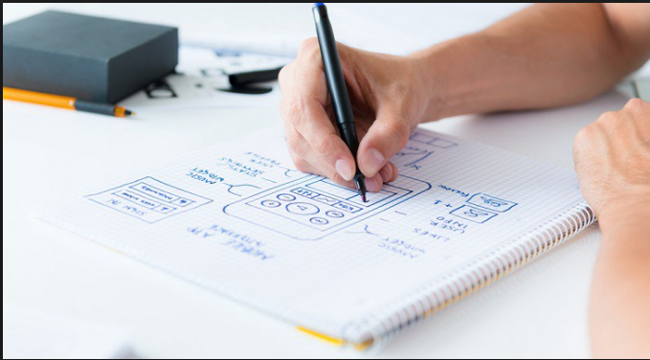

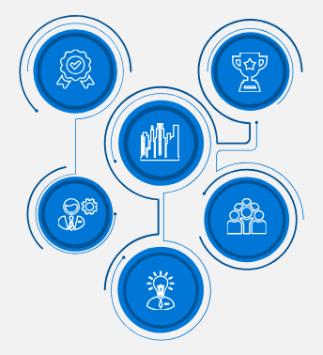
KeyBenefits OfChoosing Us

Footer

RFQ form

Portfolio Slider

